**Emmanuel Sankoh**

**SCCJ/01438/2019**

**Objective**:

The objective of this website is to help patients receive medical services that do not require them to be physically present with the doctors.

It also aims at helping patients to receive services faster and at the comfort of their homes without having to travel to the medical center and queuing, thus saves time.

**Functionalities**:

This website enables users to access their medical data records.

The site has a sign up and login page where users can create an account to view their medical records and as well as the general medical statistics of other patients who have visited the hospital, without the hospital in any way disclosing private and personal medical data of individuals.

Patients who have received services at this hospital can also book appointments with doctors through this site as long they have an account.

This is the first page having an option to sign in so as to continue:

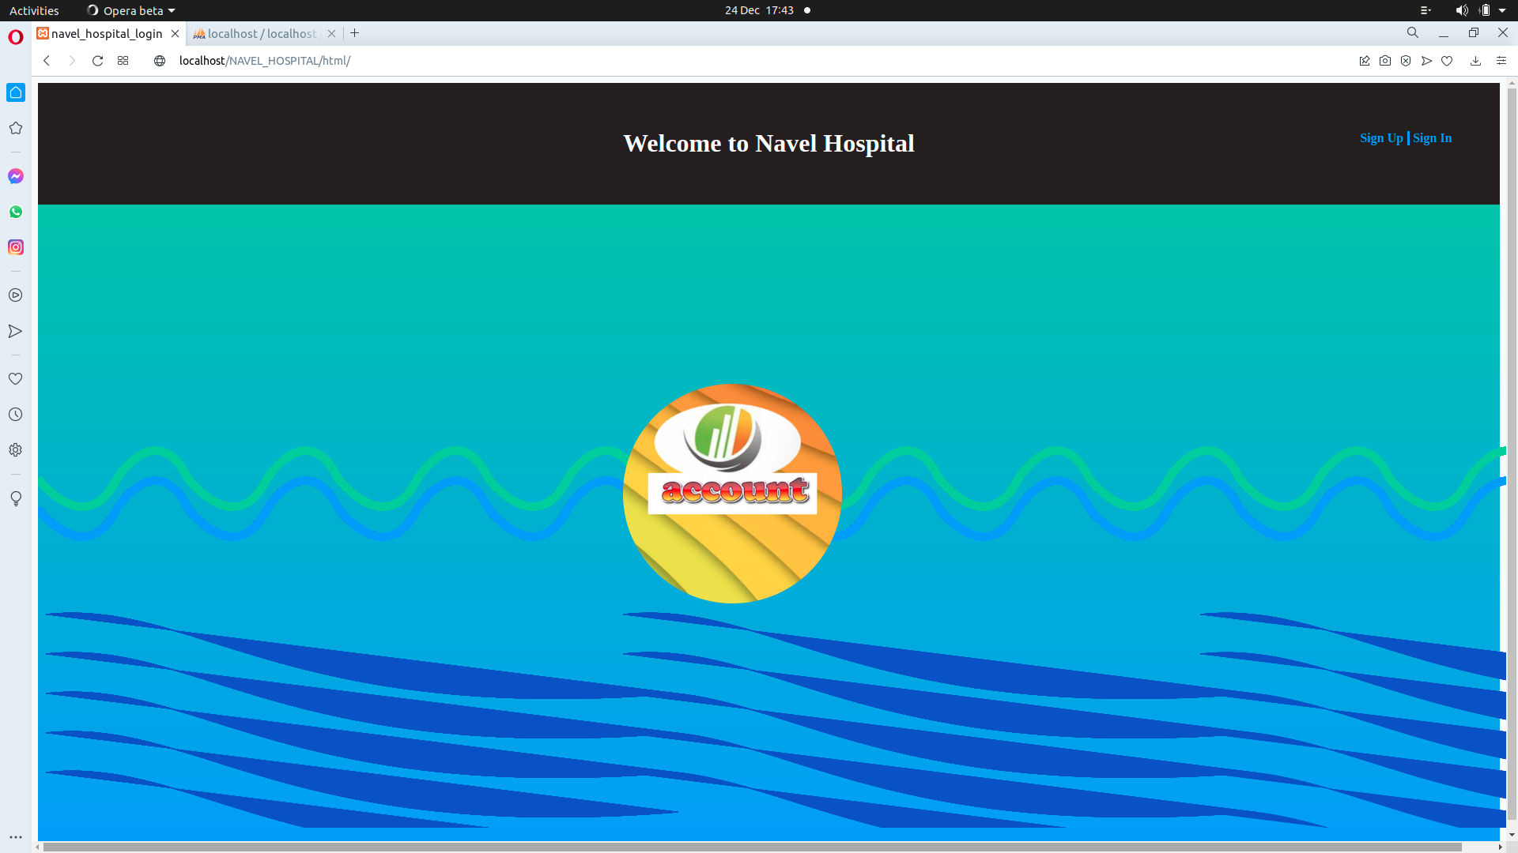

One should have already had services at this hospital before to be able to create an account.

This site needs thousands of records to be practical. But few records have been used for practical purposes. This is the list of patients who have attended this hospital. To create an account, assume the credentials of any of them to continue. Here is the DB, a MySql database of course. I’ll use the first one.

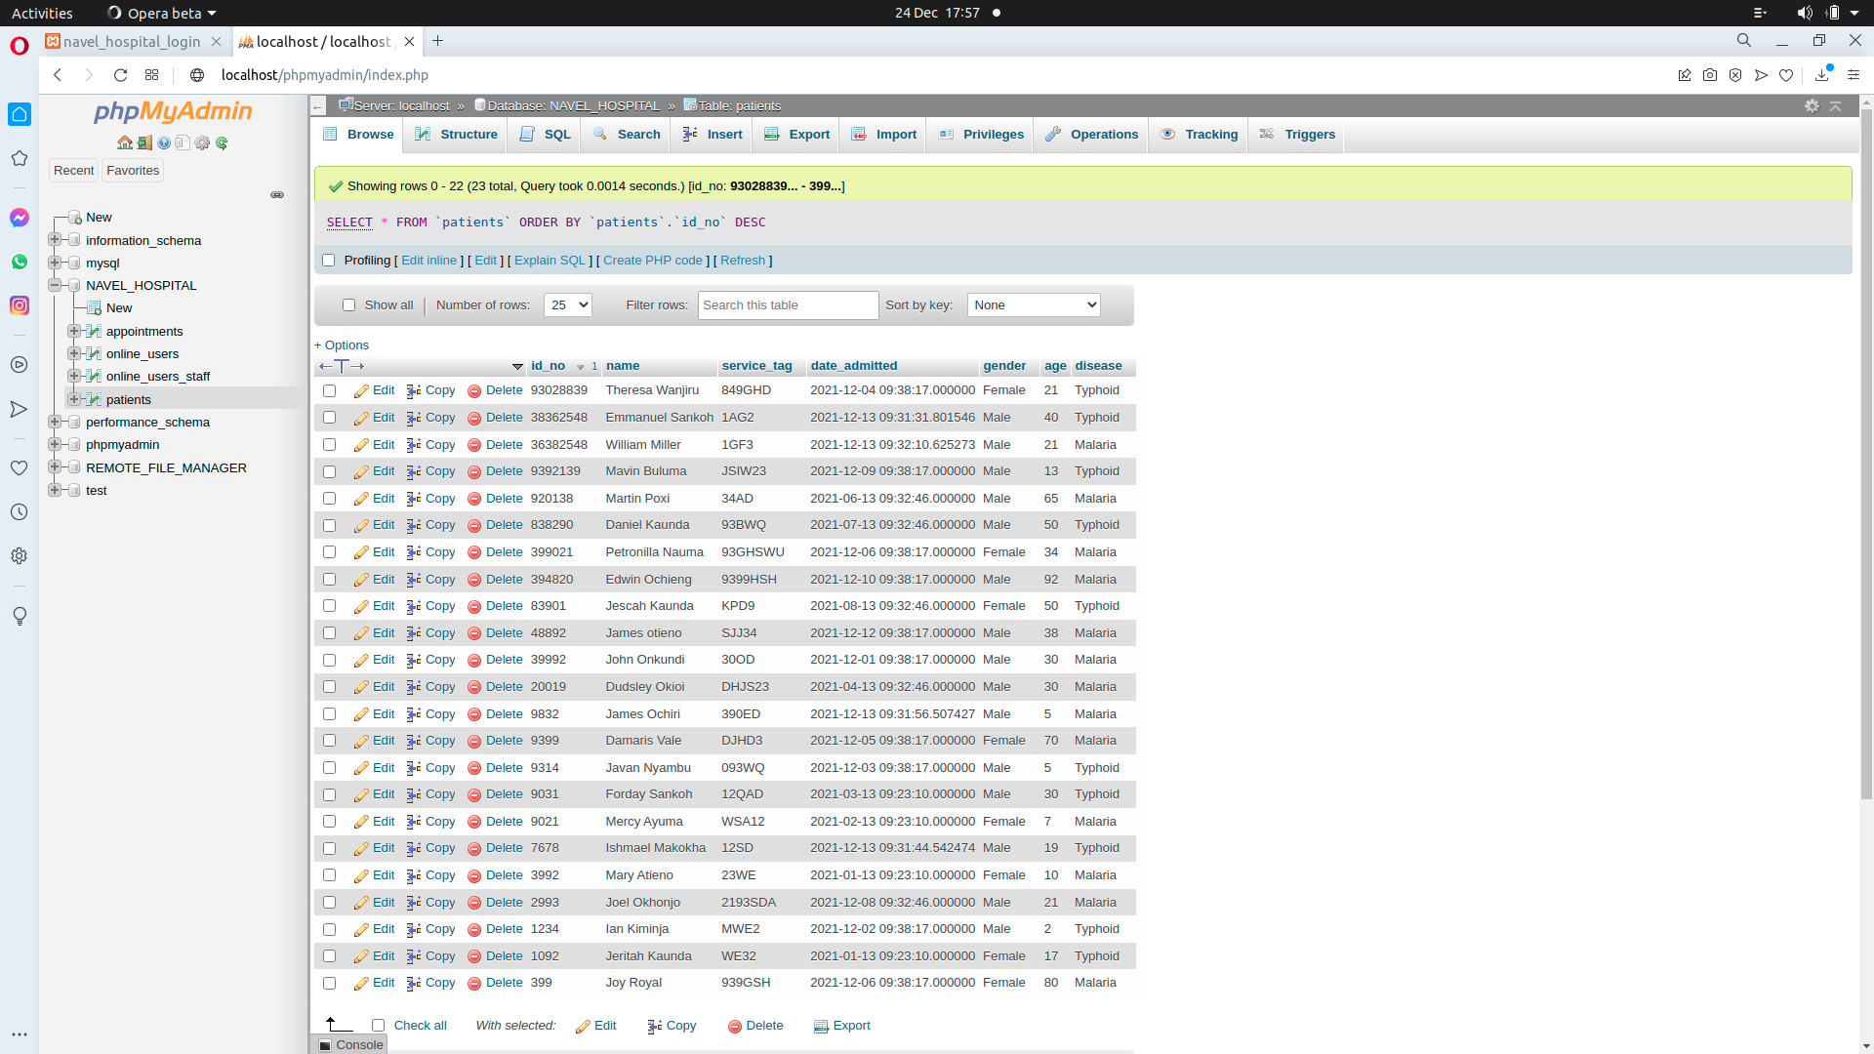

**SIGN UP**

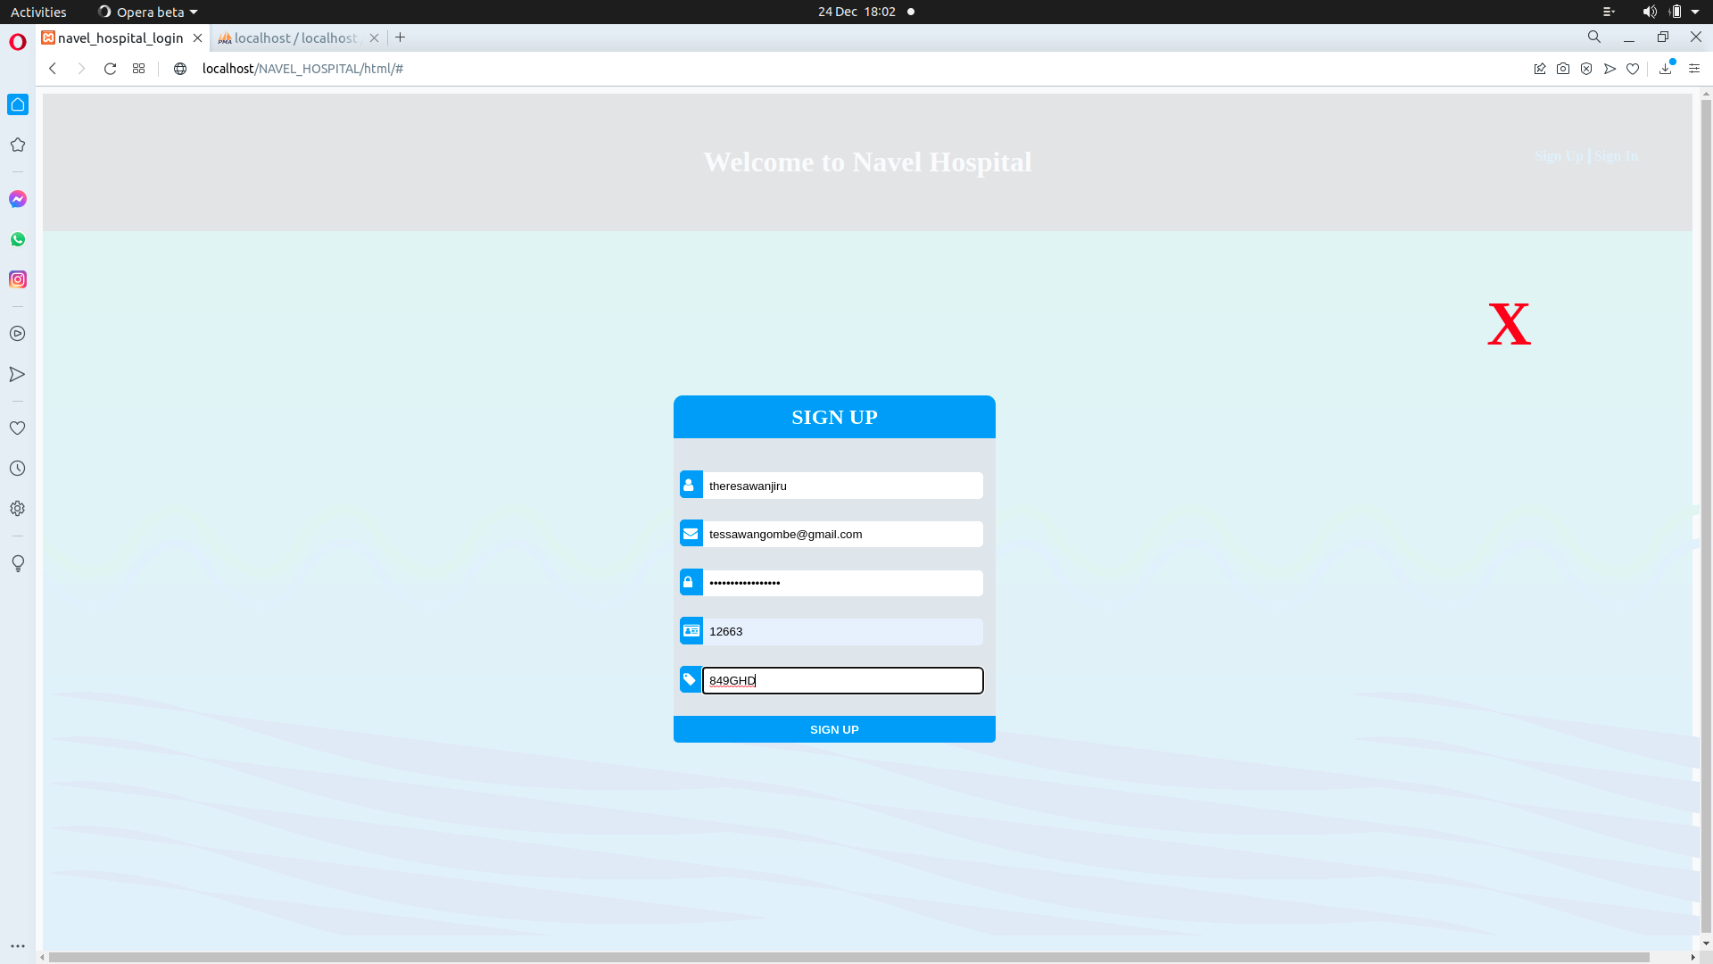

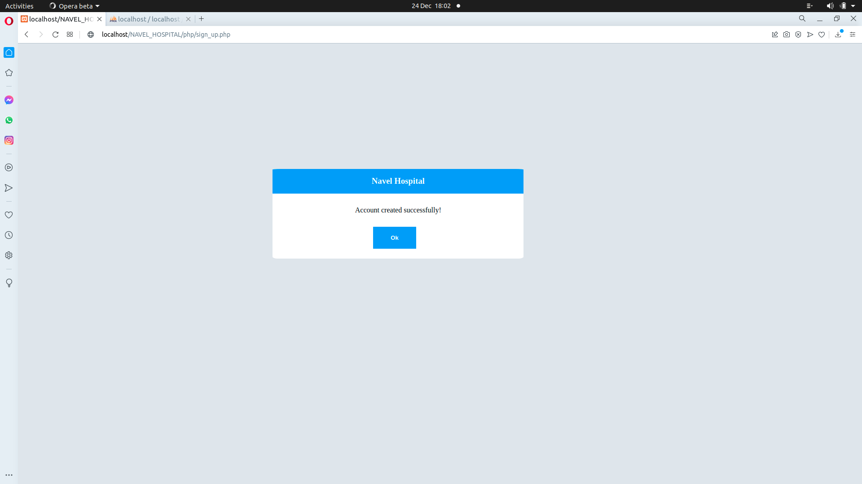

When you input wrong credentials i.e, the service tag has been entered wrongly.

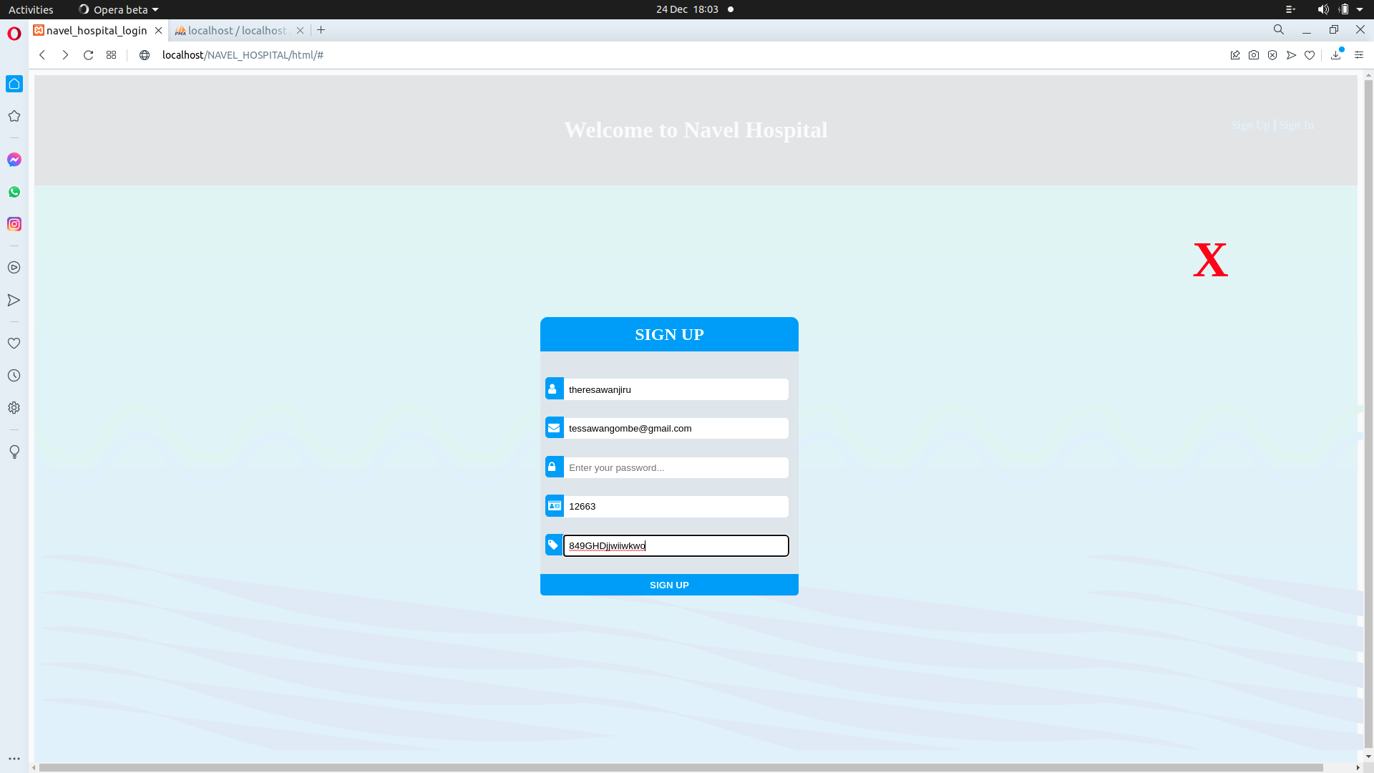

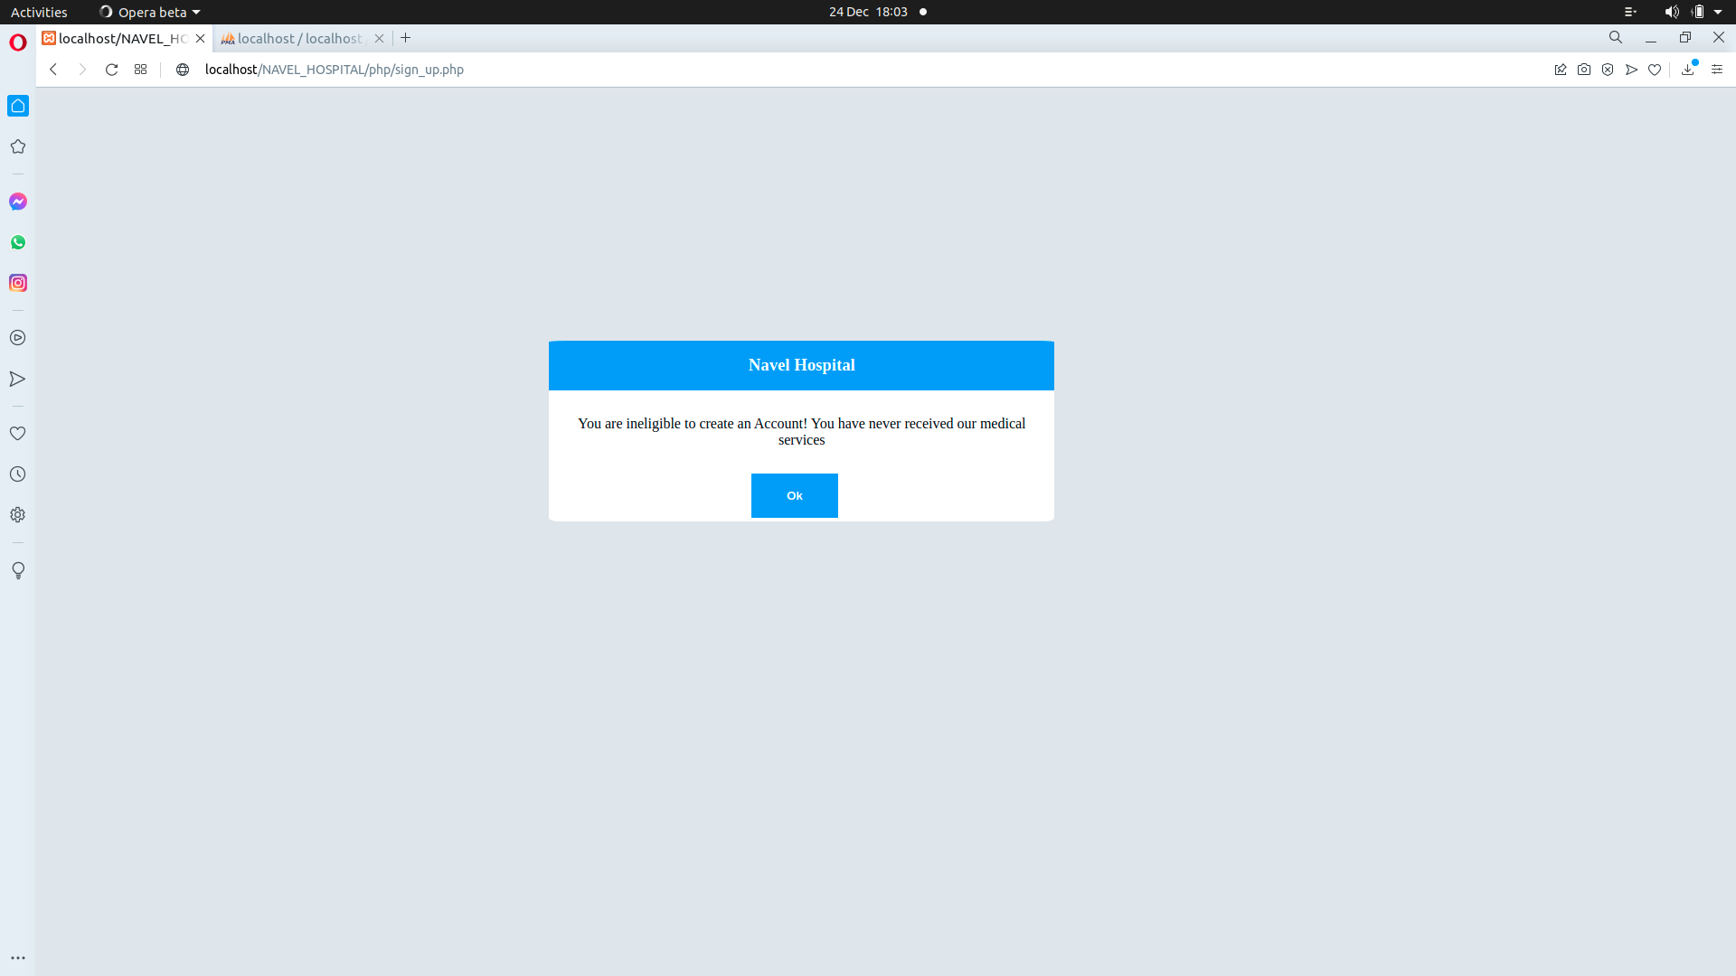

**LOGIN**

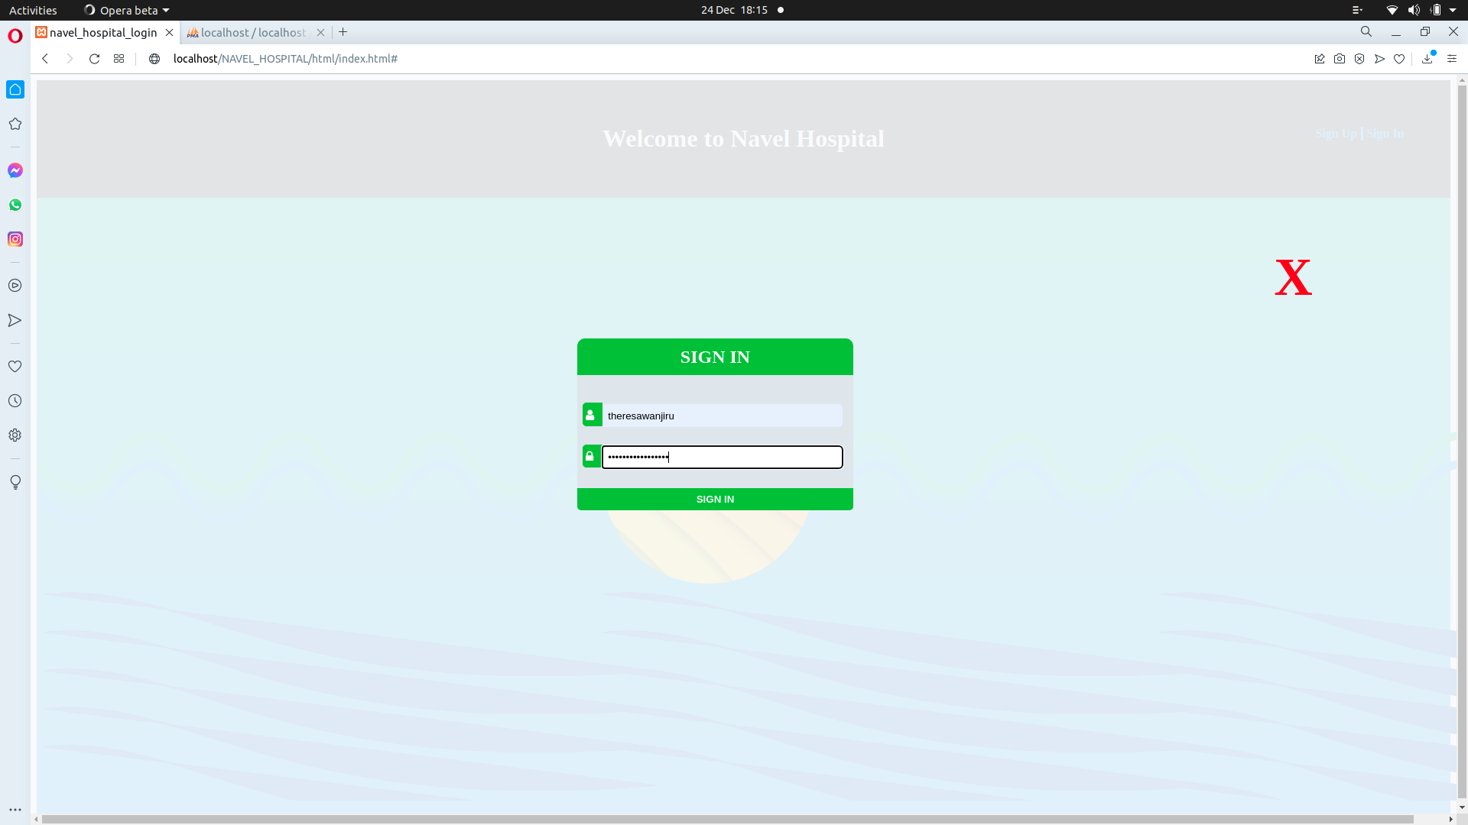

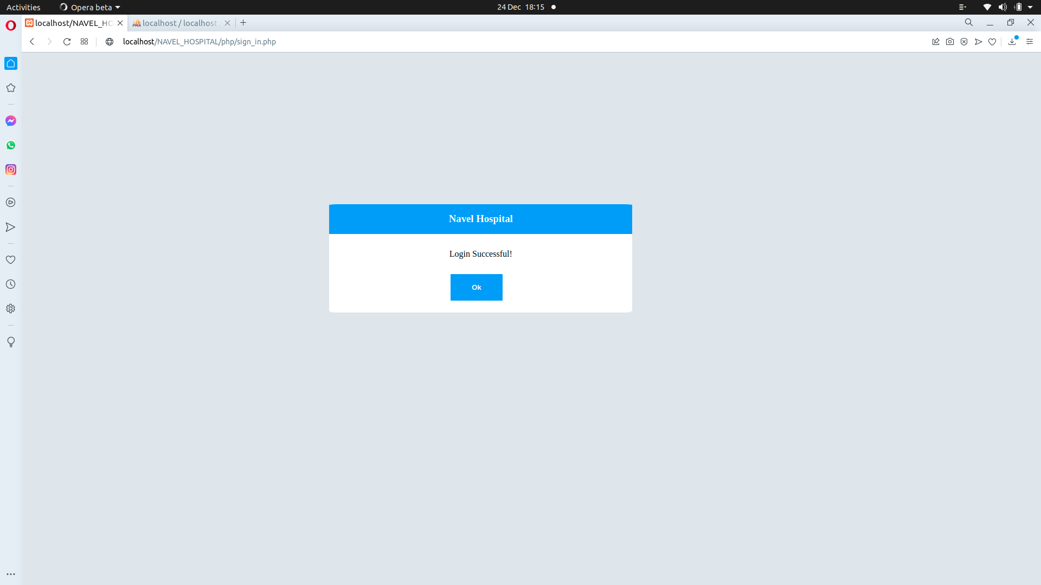

Wrong credentials

